Random Forest Algorithm

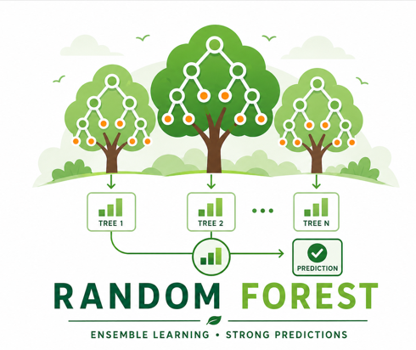

A random Forest is machine Learning algorithm that consist of multiple decision trees, each decision tree is trained on random subset of the data & features. The final prediction is made by averaging the predictions (in a regression tasks) or taking the majority vote (in classification task) from all the trees in the forest. This ensemble approach improves the accuracy and robustness of the model by reducing the risk of overfitting compared to using a single decision tree

